Mohit Pathak
Batch:11 (11:30 am)
3-Tier architecture

To create the 3 Tier architecture requirements:
- Create 3 Virtual Machines.
- VM-WEB
- VM-APP
- VM-DB
- TOMCAT installation process.
- MySQL DB installation process.

1) Created 3 Virtual Machines:
- WEB VM
- APP VM
- DB VM
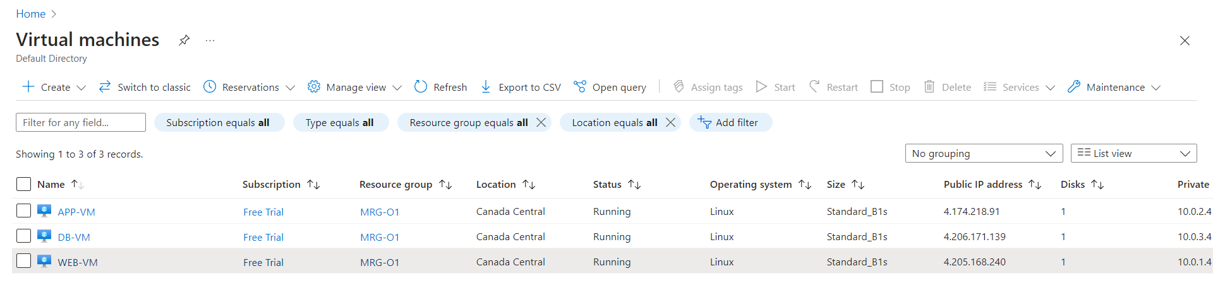
In WEBSERVER install nginx:
Connect to WEB-VM through Putty using public IP address
- sudo su
- apt update
- apt install nginx -y

while creating VM we can install nginx
put this in advance settings
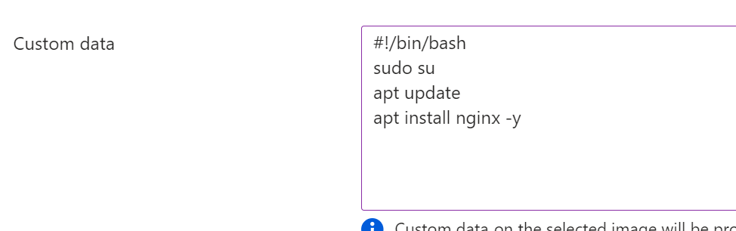

2)Tomcat installation process.
TOMCAT INSTALLATION ON UBUNTU:
Connect to APP-VM through Putty tool using public ip address.
- sudo su
- apt update -y
- apt install maven
- apt install openjdk-17-jdk -y
Go to google and browse tomcat 10 download or follow through the below link:
https://tomcat.apache.org/download-10.cgi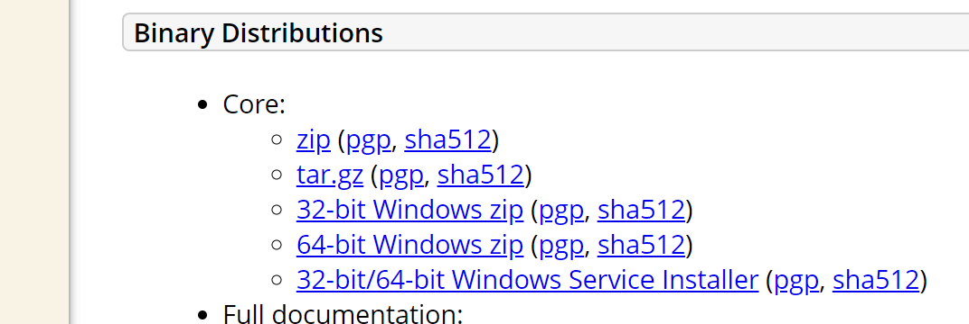
copy the path from 
- wget https://dlcdn.apache.org/tomcat/tomcat-10/v10.1.28/bin/apache-tomcat-10.1.28.tar.gz (past the url)
- ls
- tar -xvzf apache-tomcat-10.1.28.tar.gz
- ls
- mv apache-tomcat-10.1.28 tomcat
- ls
- cd tomcat/
- ls
- cd webapps/
- ls
- cd host-manager/
- ls
- cd META-INF/
- ls
- vi context.xml
<!-- Valve className="org.apache.catalina.valves.RemoteAddrValve"
allow="127\.\d+\.\d+\.\d+|::1|0:0:0:0:0:0:0:1" / -->
enter !-- & -- (as highlighted above)
- cd ..
- cd ..
- cd ..
- cd conf/
- ls
- vi tomcat-user.xml ( enter tom&tab to fill)
copy below code & past as shown below fig1:
code
<role rolename="manager-gui" />
<user username="manager" password="manager_password" roles="manager-gui" />

<role rolename="admin-gui" />
<user username="admin" password="admin_password" roles="manager-gui,admin-gui" />
<user username="tomcat" password="tomcat" roles="manager-gui,manager,manager-jmx,manager-script,admin,admin-gui" />

FiG1:
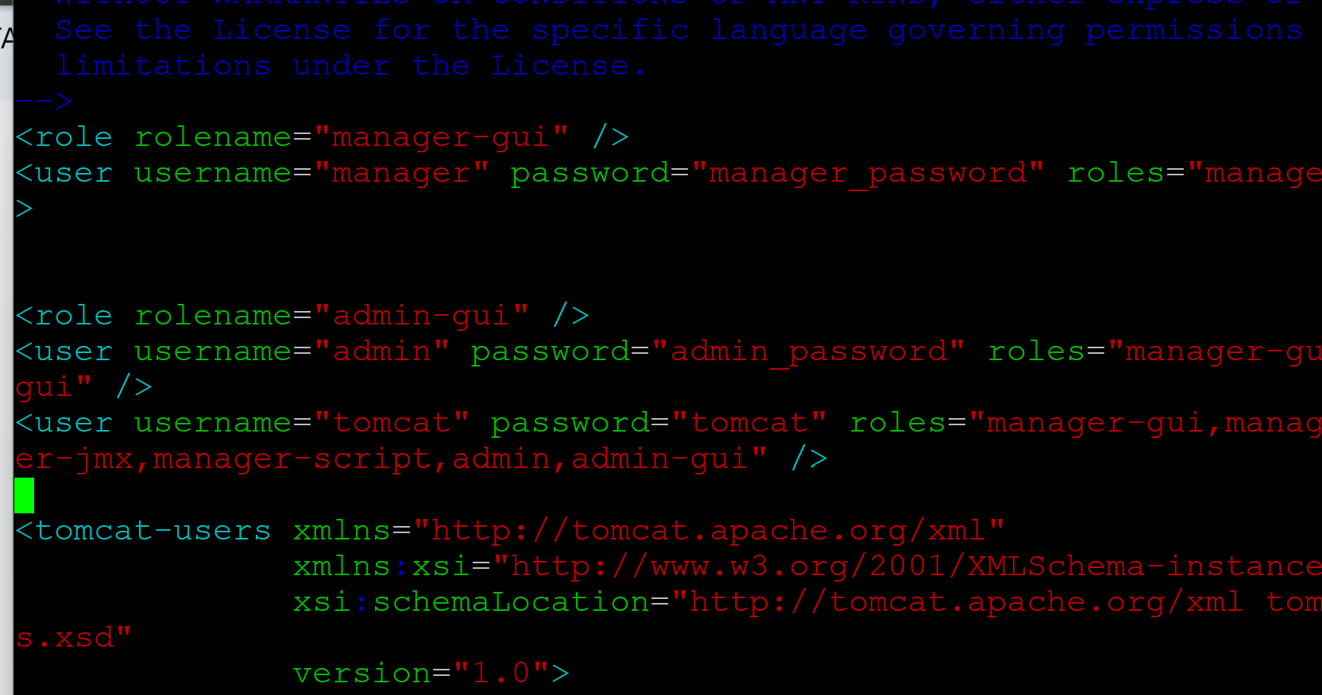
- cd ..
- ls
- cd webapps/
- ls
- cd manager/
- ls
- cd META-INF/
- ls
- vi context.xml
<!-- Valve className="org.apache.catalina.valves.RemoteAddrValve"
allow="127\.\d+\.\d+\.\d+|::1|0:0:0:0:0:0:0:1" / -->
- enter !-- & -- (as highlighted above)
- cd ..
- cd ..
- cd ..
- cd conf/
- ls
- cd ..
- ls
- cd bin
- ls
- ./shutdown.sh
- ./startup.sh
- Cd ../..
Installations completed
Enter public IP address with : & 8080(ex:-172.167.208.125)
Check it was working or not.

Installations completed successful
Connected to APP-VM with public IP:
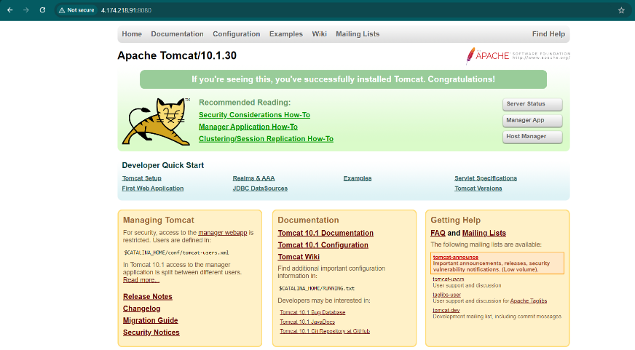

- MySQL DB Installation Process.

install MySQL DB on Linux machine using the below commands:
- Sudo su – root user.
- apt update —update the machine.
- apt install mysql-server -y ---- install my sql server.
- systemctl start mysql.service --- start the my sql server.
- systemctl status mysql ---- check the status whether it is in active &amp; running or not.
- systemctl enable mysql ----- enable my sql in your system.
- mysql_secure_installation .
- y
- y
- 2

- Y
- Y
- y
- mysql --- login into the mysql &amp; check the , exit from my sql.
- ctrl+z.
- nano /etc/mysql/mysql.conf.d/mysqld.cnf -----→edit the file as,
(blind-address&amp- 0.0.0.0
mysqlx-blind-address- 0.0.0.0)

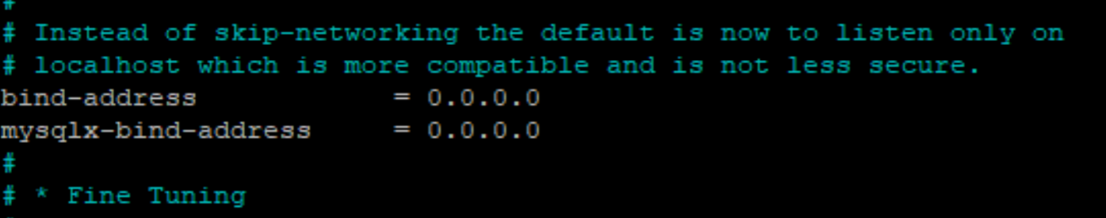

After this do ctrl+x to save
Yes -y
enter

- systemctl restart mysql -→restart my sql
- service mysql restart --→ restart my sql service
- systemctl status mysql.service --→check the status
- after successful installation you will be able to see the putty console like below
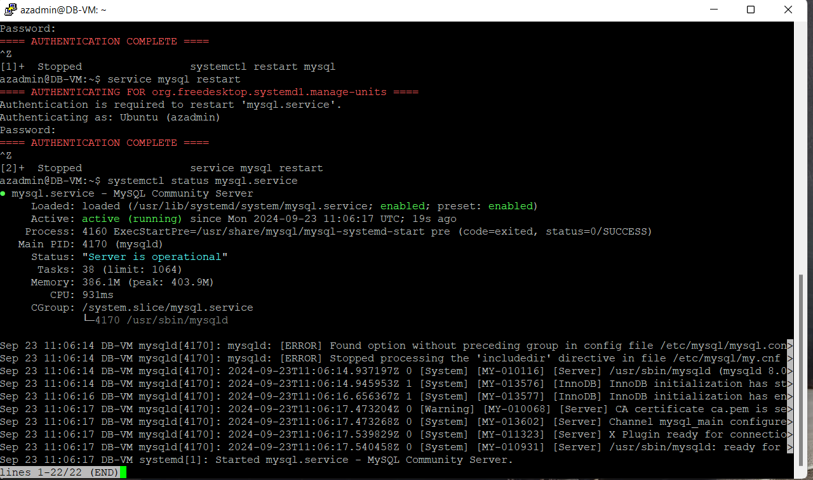

now go to your azure portal write the NSG rules as below as per your requirement…
NSG RULES:
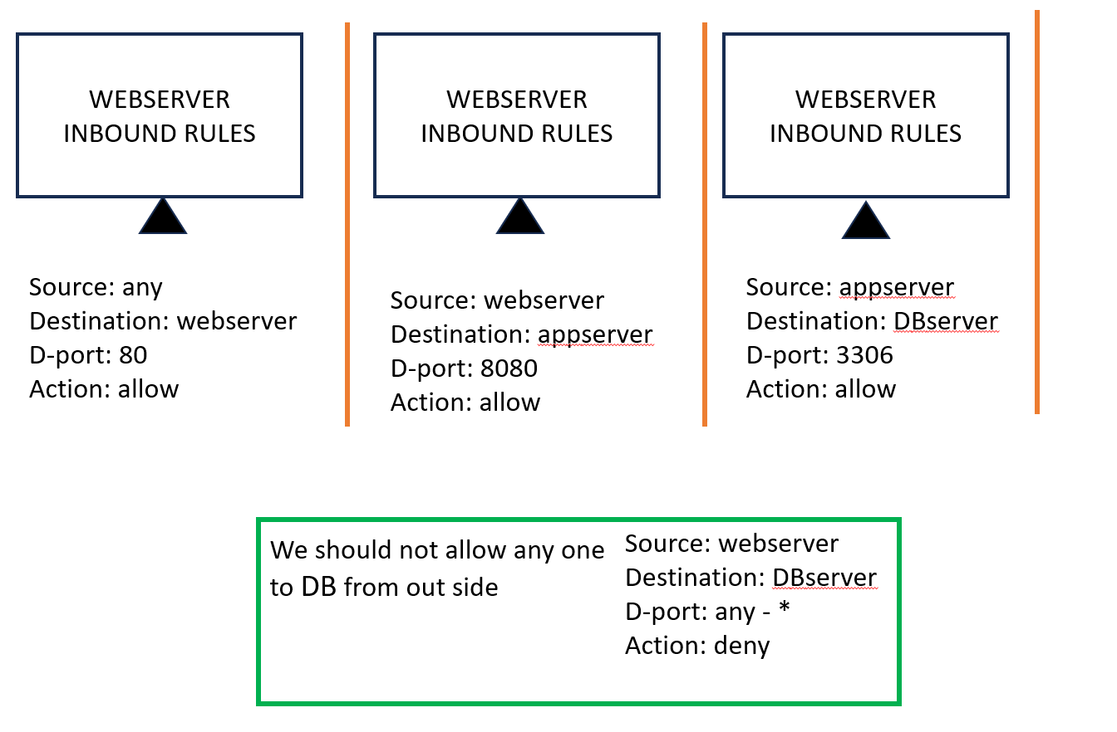

Results:

- Anyone should be able to access WEB-VM on port 80 [ it should be accessible via browser]
  - Yes, connected to WEB-VM on 80 via browser.
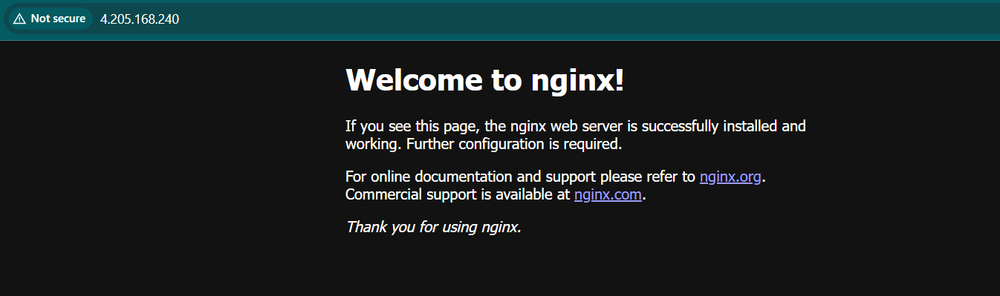

2. By using telnet command from WEB-VM, Result should be able to get connect to APP-VM on port 8080.
  - Yes, connected to APP-VM on 8080 via WEB-VM.
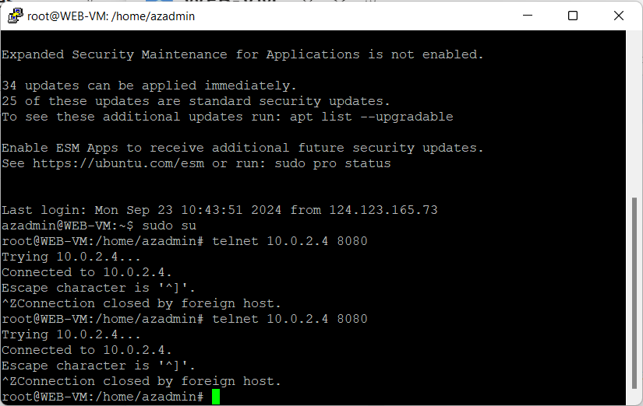

3. telnet from APP-VM to DB-VM server on port 3306/1433 result should be connected.

  - Yes, connected to DB-VM on 3306 via APP-VM.
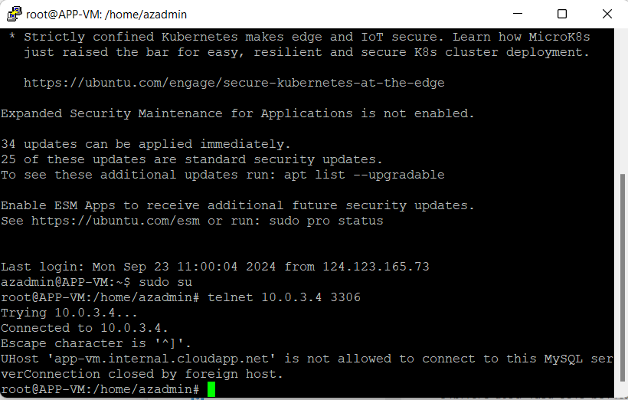

4. By using telnet command from WEB-VM, Result should not get connect to DB-VM on any port
Result ⇒ no connection, or connection refused.

- Yes, connection refused to DB-VM on 3306 via WEB-VM.
